Dear Substitute Teacher,

Thank you for filling in today! Students will be working on an artificial intelligence (AI) literacy project about disinformation spread through AI generated deepfakes.


This playbook contains the complete lesson plan with step-by-step instructions.

If you're interested in learning more about the topic, turn to the end of this playbook to find an optional section with additional background information and examples.

Thank you! 🤗

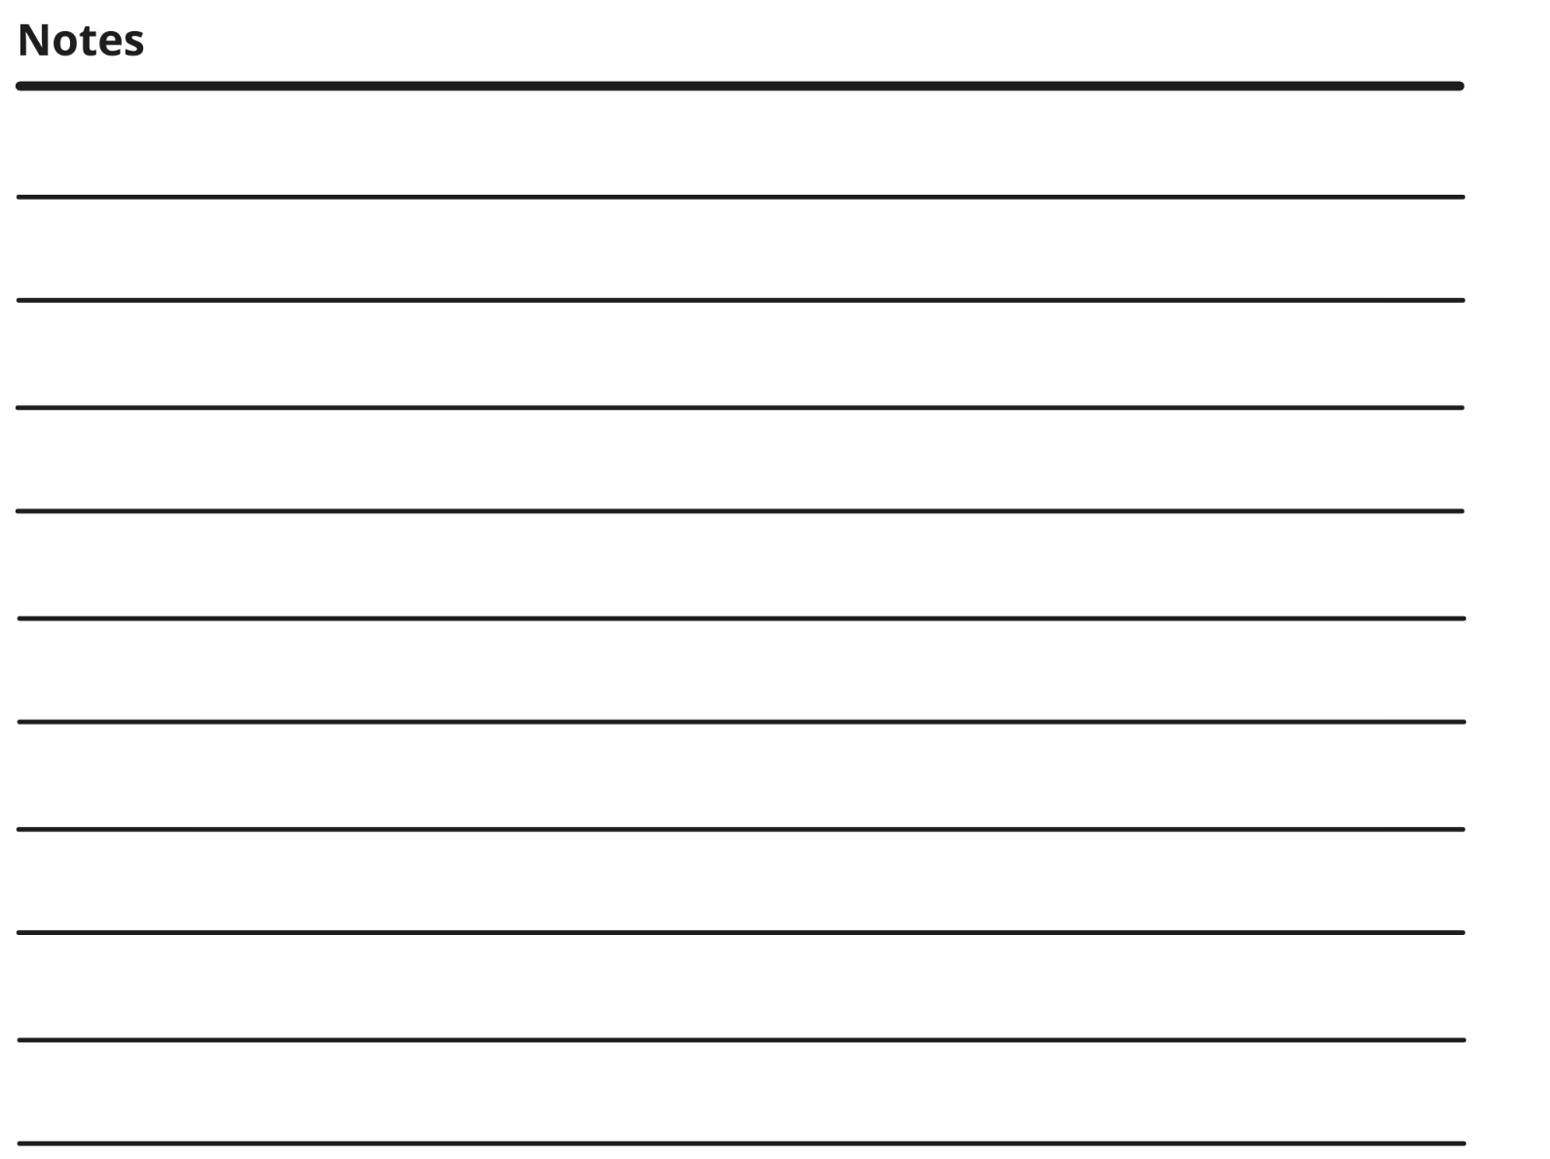


🚦Start Here:

- RECORD Attendance
- DISTRIBUTE ONE (1) Student Guide to each student

👋🏽 If students ask, “what are we doing” or “why are we doing this” say:

🎤Today you're creating a Public Service Announcement to educate your community about deepfakes and disinformation created with artificial intelligence (AI). Your teacher wants you to LEARN and SHARE how to identify deepfake videos and images, so you can be responsible consumers of information in the age of AI.

- PROCEED with the option that works best for YOU:

Student-led |  | Teacher-led
Allow students to work independently on the activities outlined in the Student Guide. This option is suitable if students are capable of self-directed learning and time management. | OR | Follow the step-by-step instructions on the next page to lead students through the activities in the Student Guide. This option provides more structure and is recommended if students require additional support or guidance.

Teacher-led, step-by-step instructions start on the next page.
▼

Teacher-Led
Step-by-step instructions

Step 1 | Opening Exercise: Which Image is Fake?  Learn how to identify fake generated images | ⏱️5 mins
- ASK students to review Page 1 (activity 3) of their Student Guide to figure out which image is fake.

Optional Asks:
- Ask them to chat with their table/partner next to them.
- Which photo is fake? How do you know?
🔑Answer Key: The left image is fake, you can tell because:
- The front teeth are not the same size.
- There is clear digital distortion in the background.
- There is distorted scarring on her cheeks.
TRANSITION TO NEXT STEP | 🎤These images were generated by AI technology. At first glance, they could both look real, right? This goes for video as well. Next, let’s look at the definition of a deepfake.

 | Step 2 | Fundamentals: Reviewing the Terminology  Understand the basic definitions of AI and deepfakes. |  | ⏱️10 mins
- ASK for a volunteer to read the definition of a deepfake on Page 2 (activity 4) of the Student Guide.

Encourage students to UNDERLINE or HIGHLIGHT important keywords or concepts.

- ASK does anyone know an example of a deepfake?

Some examples:
- Has anyone tried a face-swap app?
- Deepfakes include a fake TikTok video of influencer McBeast offering $2 iPhones to his 202 million followers, and a fake video of Senator Elizabeth Warren saying that Republicans shouldn’t be allowed to vote (NBC, Oct 2023)
 | TRANSITION TO NEXT STEP | 🎤Before we dive in, take five minutes to check out “AI in 5 Minutes” to learn about artificial intelligence at large and what it means.

 | Step 3 | Understanding Deep Fakes  Understand examples of deepfakes and explore the ramifications on society. |  | ⏱️15 mins
- ASK students to watch the “Deepfakes” video on their device. Students can enter the URL on their device or scan the QR code on Page 3 (activity 8) of the Student Guide.

OR (if available) PLAY the “Deepfakes” video on the classroom projector.

Optional Asks:
  - Can you describe one example of a deepfake? (Reflection question on Student Guide Page 3, Activity 9)

- ASK a volunteer to read out loud the definition of democracy on Page 4 (activity 10) of the Student Guide:

- DIRECT students to Page 4 of the Student Guide where they can reflect on positive and negative impacts of deepfakes:

🎤What is one way deepfakes can have a positive impact on democracy? What is one way they can have a negative impact? Answer the reflection questions (activities 11-12).

 | Step 4 | How to Write a Press Release  Understand the basic format of a press release, and how to judge its effectiveness. |  | ⏱️30 min
 |  | - ASK students to read both press releases and complete the question “Which press release is more effective?” on Page 6 of the Student Guide (activities 16-17).
Optional Ask:
- Which press release is more effective? Why?

Answer Key:
- Press Release #1 lists the positive impacts of deepfakes, but no negatives.
- Press Release #2 lists both positive and negative impacts of deepfakes, details WHAT the administration is doing to address the harms, and has a strong concluding statement.

 | Step 5 | Students Write Their Own Press Release  Write a fact-based and balanced press release showing understanding of the ramifications of deepfakes. |  | ⏱️60 min
- ASK students to write an outline for their press release.

🎤Now, we’re going to write our own press release template. Using what you learned from the Deepfakes video and the How to Detect a Deepfake sheet, fill out the Press Release Outline template on Page 10. The instructions are on Page 9 of your Student Guide.

⏰Students should aim to complete their outline in about 15 minutes.

- When they are ready, ASK students to use the Press Release template to draft their press release.

🎤Now, use the Press Release template on Page 11 of your Student Guide to write a draft of your press release.

⏰Students should aim to complete their press release in about 45 minutes.
🏁Step-by-step instructions end here.

🤿Diving Deeper: Check out the next page for (optional) background information and examples on the lesson topic.


For Your Information (optional)
Background and further reading

The Point: AI-generated deepfakes—fake photos, video, audio— have emerged as a potential source of fake news. Since the majority of people in today’s society get their information from Internet content, deepfakes could have serious consequences on a micro and macro scale.
Civic leaders should educate and prepare the public for ways to watch out for deep fakes, and how they might influence their perspective.

How serious is this problem, really?

- The proliferation of deepfakes across the Internet is rapid–the total amount has been doubling every six months. In 2018, there were approximately 7,964 deepfakes; the number jumped to 85,047 in December 2020.

- Inexpensive apps and software have made it possible for amateurs to make convincing deepfakes.

- It’s not just the United States where ramifications across elections, consumer data safety, and personal reputation are clear. In 2020, the Indian BJP government partnered with a communications firm to create deepfake videos, to discourage voters from casting ballots for a rival, reaching 15 million people in 5,800 WhatsApp groups. (MIT, 2020)
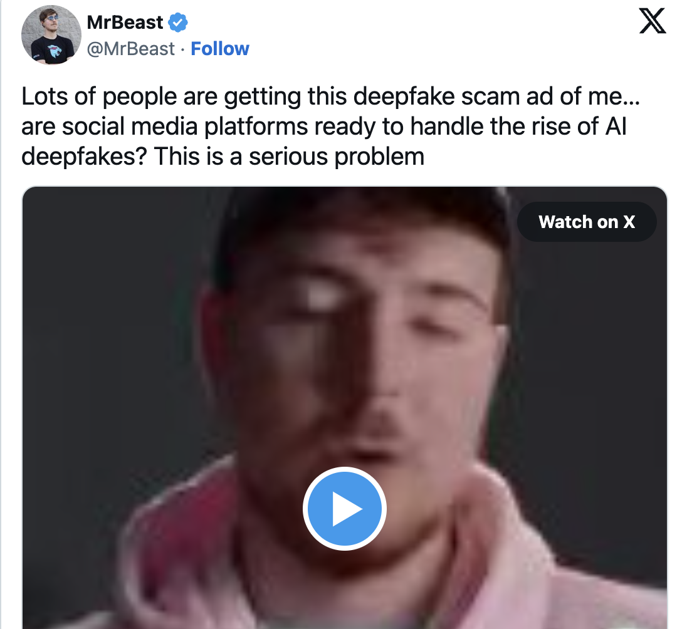
Examples of deep fakes:

- A fake TikTok video of influencer McBeast offering $2 iPhones to his 202 million followers (NBC, Oct 2023)
- An altered video of Senator Elizabeth Warren, making it appear she said that Republicans should not be allowed to vote. (Politifact, Feb 2023)
- Actress Emma Watson’s voice simulated to be “reading” Mein Kampf (Vanity Fair, 2023)

What are the ways we can detect deepfakes?
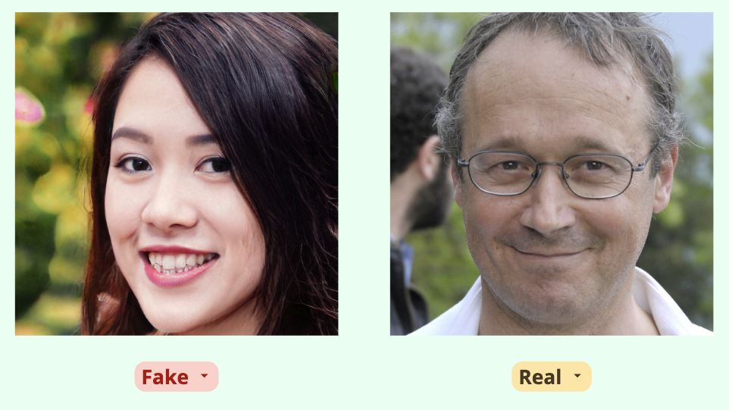
- Look closely at the subject’s face and ask yourself:
  - Is the face too smooth? Do the eyelid and mouth movements seem disjointed, forced, or unnatural? Does the hair look fake?

- Research the context (The Conversation, July 2022):
  - Search online for keywords about the video, as many suspicious deepfakes will have already been debunked.
  - Search keywords used in the video to see if there’s a public transcript of what’s being said–outlets often cover quotes by high profile people.
  - Is the poster’s account verified?
  - Take a screenshot of the video playing and do a Google reverse image search to reveal if the original version of the video exists.

Articles for further reading:
- Celebrity deepfakes are all over TikTok. Here’s why they’re becoming common–and how can you spot them (The Conversation, July 2022)
- How real is the threat of AI deepfakes in the 2024 election? (NPR, July 2023)
- Deepfakes 101: Towards a Discerning Public (MIT, Online Only)
- Media Literacy in the Age of Deepfakes Reading List (MIT)



